**ASSIGNMENT (13.06.24)**

**1.Height of Binary Tree After Subtree Removal Queries**

You are given the root of a binary tree with n nodes. Each node is assigned a unique value

from 1 to n. You are also given an array queries of size m.You have to perform m

independent queries on the tree where in the ith query you do the following:

● Remove the subtree rooted at the node with the value queries[i] from the tree. It is

guaranteed that queries[i] will not be equal to the value of the root.

Return *an array* answer *of size* m *where* answer[i] *is the height of the tree after performing*

*the* ith *query*.

Note:

● The queries are independent, so the tree returns to its initial state after each query.

● The height of a tree is the number of edges in the longest simple path from the root to

some node in the tree.

Example 1:

Input: root = [1,3,4,2,null,6,5,null,null,null,null,null,7], queries = [4]

Output: [2]

Explanation: The diagram above shows the tree after removing the subtree rooted at node

with value 4.

The height of the tree is 2 (The path 1 -> 3 -> 2).

Example 2:

Input: root = [5,8,9,2,1,3,7,4,6], queries = [3,2,4,8]

Output: [3,2,3,2]

Explanation: We have the following queries:

- Removing the subtree rooted at node with value 3. The height of the tree becomes 3 (The

path 5 -> 8 -> 2 -> 4).

- Removing the subtree rooted at node with value 2. The height of the tree becomes 2 (The

path 5 -> 8 -> 1).

- Removing the subtree rooted at node with value 4. The height of the tree becomes 3 (The

path 5 -> 8 -> 2 -> 6).

- Removing the subtree rooted at node with value 8. The height of the tree becomes 2 (The

path 5 -> 9 -> 3).

Constraints:

● The number of nodes in the tree is n.

● 2 <= n <= 105

● 1 <= Node.val <= n

● All the values in the tree are unique.

● m == queries.length

● 1 <= m <= min(n, 104)

● 1 <= queries[i] <= n

● queries[i] != root.val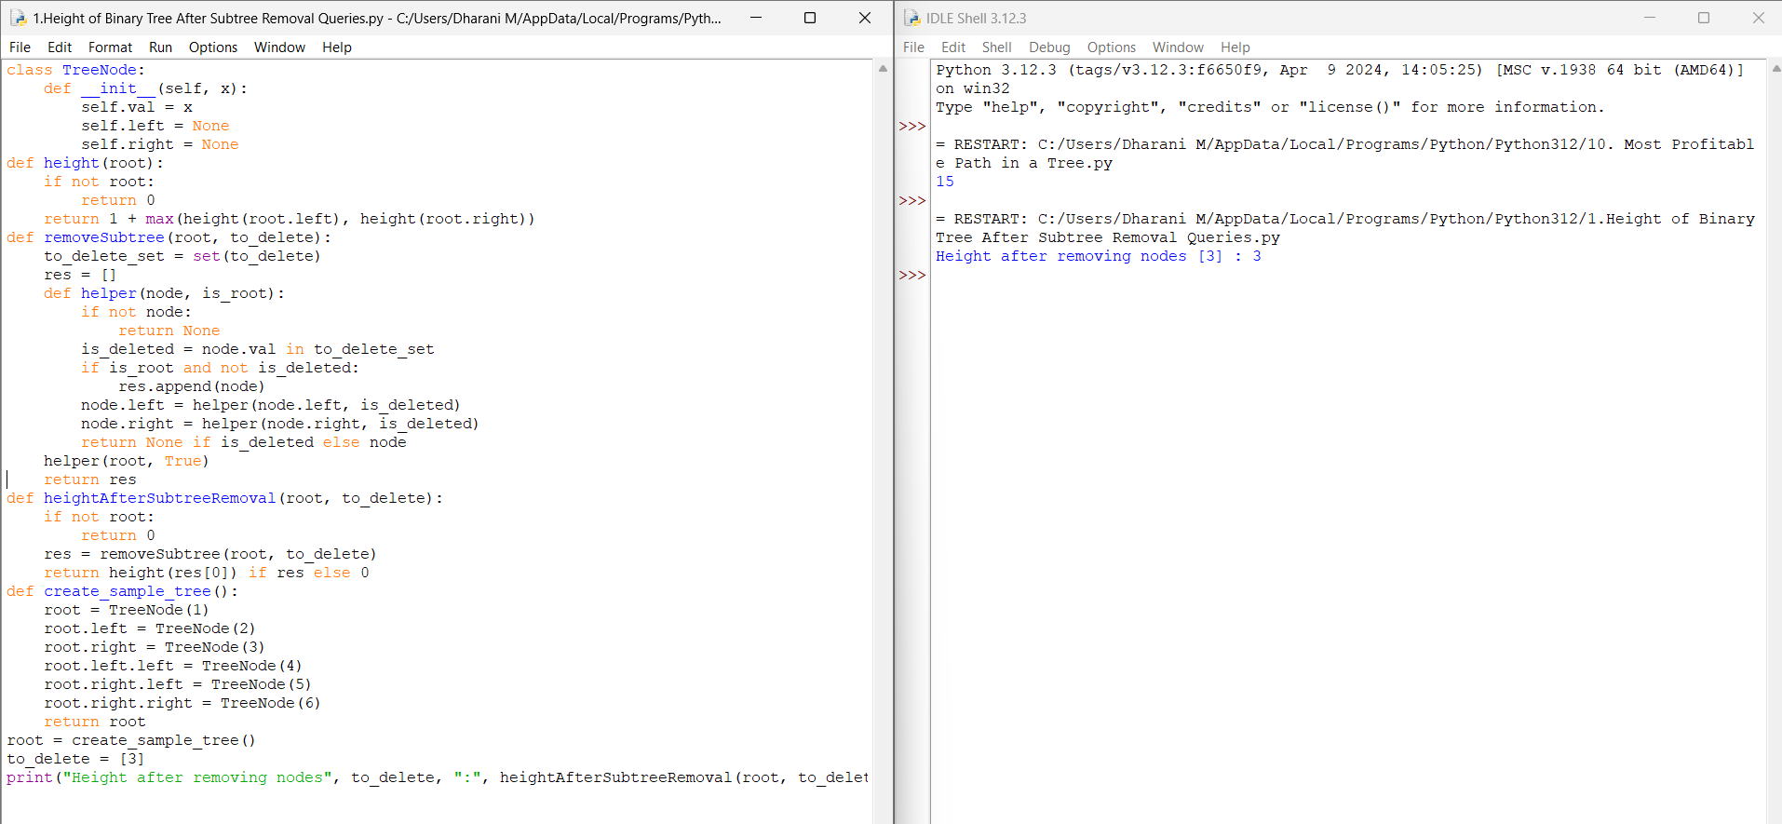

**2. Sort Array by Moving Items to Empty Space**

You are given an integer array nums of size n containing each element from 0 to n - 1

(inclusive). Each of the elements from 1 to n - 1 represents an item, and the element 0

represents an empty space.

In one operation, you can move any item to the empty space. nums is considered to be sorted

if the numbers of all the items are in ascending order and the empty space is either at the

beginning or at the end of the array.

For example, if n = 4, nums is sorted if:

● nums = [0,1,2,3] or

● nums = [1,2,3,0]

...and considered to be unsorted otherwise.Return *the minimum number of operations needed*

*to sort* nums.

Example 1:

Input: nums = [4,2,0,3,1]

Output: 3

Explanation:

- Move item 2 to the empty space. Now, nums = [4,0,2,3,1].

- Move item 1 to the empty space. Now, nums = [4,1,2,3,0].

- Move item 4 to the empty space. Now, nums = [0,1,2,3,4].

It can be proven that 3 is the minimum number of operations needed.

Example 2:

Input: nums = [1,2,3,4,0]

Output: 0

Explanation: nums is already sorted so return 0.

Example 3:

Input: nums = [1,0,2,4,3]

Output: 2

Explanation:

- Move item 2 to the empty space. Now, nums = [1,2,0,4,3].

- Move item 3 to the empty space. Now, nums = [1,2,3,4,0].

It can be proven that 2 is the minimum number of operations needed.

Constraints:

● n == nums.length

● 2 <= n <= 105

● 0 <= nums[i] < n

● All the values of nums are unique.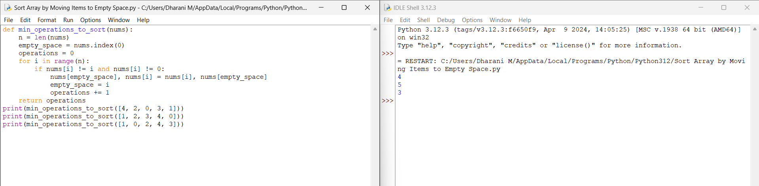

**3. Apply Operations to an Array**

You are given a 0-indexed array nums of size n consisting of non-negative integers.You need

to apply n - 1 operations to this array where, in the ith operation (0-indexed), you will apply

the following on the ith element of nums:

● If nums[i] == nums[i + 1], then multiply nums[i] by 2 and set nums[i + 1] to 0.

Otherwise, you skip this operation.

After performing all the operations, shift all the 0's to the end of the array.

● For example, the array [1,0,2,0,0,1] after shifting all its 0's to the end, is [1,2,1,0,0,0].

Return *the resulting array*.Note that the operations are applied sequentially, not all at once.

Example 1:

Input: nums = [1,2,2,1,1,0]

Output: [1,4,2,0,0,0]

Explanation: We do the following operations:

- i = 0: nums[0] and nums[1] are not equal, so we skip this operation.

- i = 1: nums[1] and nums[2] are equal, we multiply nums[1] by 2 and change nums[2] to 0.

The array becomes [1,4,0,1,1,0].

- i = 2: nums[2] and nums[3] are not equal, so we skip this operation.

- i = 3: nums[3] and nums[4] are equal, we multiply nums[3] by 2 and change nums[4] to 0.

The array becomes [1,4,0,2,0,0].

- i = 4: nums[4] and nums[5] are equal, we multiply nums[4] by 2 and change nums[5] to 0.

The array becomes [1,4,0,2,0,0].

After that, we shift the 0's to the end, which gives the array [1,4,2,0,0,0].

Example 2:

Input: nums = [0,1]

Output: [1,0]

Explanation: No operation can be applied, we just shift the 0 to the end.

Constraints:

● 2 <= nums.length <= 2000

● 0 <= nums[i] <= 1000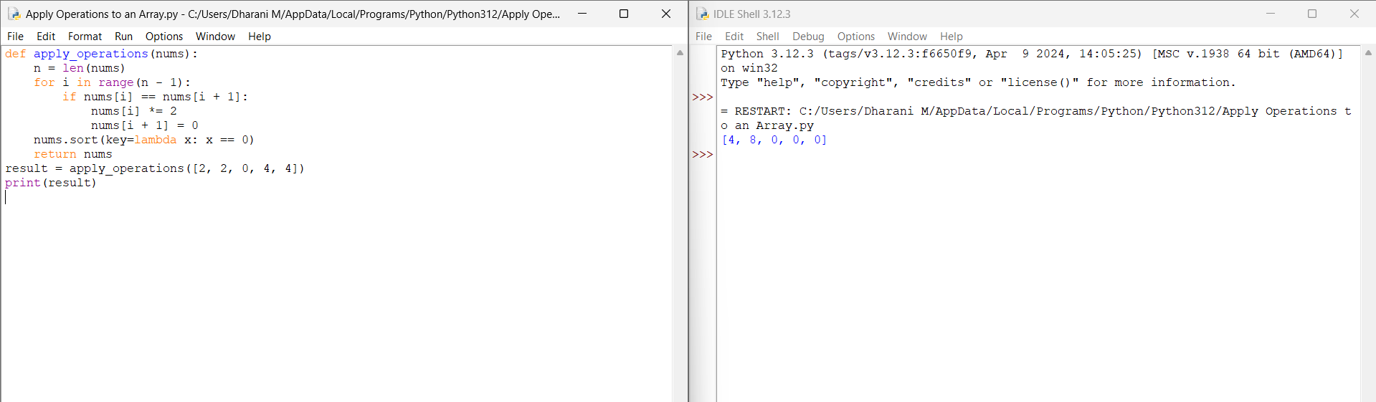

●

**4. Maximum Sum of Distinct Subarrays With Length K**

You are given an integer array nums and an integer k. Find the maximum subarray sum of all

the subarrays of nums that meet the following conditions:

● The length of the subarray is k, and

● All the elements of the subarray are distinct.

Return *the maximum subarray sum of all the subarrays that meet the conditions.* If no

subarray meets the conditions, return 0. *A subarray is a contiguous non-empty sequence of*

*elements within an array.*

Example 1:

Input: nums = [1,5,4,2,9,9,9], k = 3

Output: 15

Explanation: The subarrays of nums with length 3 are:

- [1,5,4] which meets the requirements and has a sum of 10.

- [5,4,2] which meets the requirements and has a sum of 11.

- [4,2,9] which meets the requirements and has a sum of 15.

- [2,9,9] which does not meet the requirements because the element 9 is repeated.

- [9,9,9] which does not meet the requirements because the element 9 is repeated.

We return 15 because it is the maximum subarray sum of all the subarrays that meet the

conditions

Example 2:

Input: nums = [4,4,4], k = 3

Output: 0

Explanation: The subarrays of nums with length 3 are:

- [4,4,4] which does not meet the requirements because the element 4 is repeated.

We return 0 because no subarrays meet the conditions.

Constraints:

● 1 <= k <= nums.length <= 105

● 1 <= nums[i] <= 105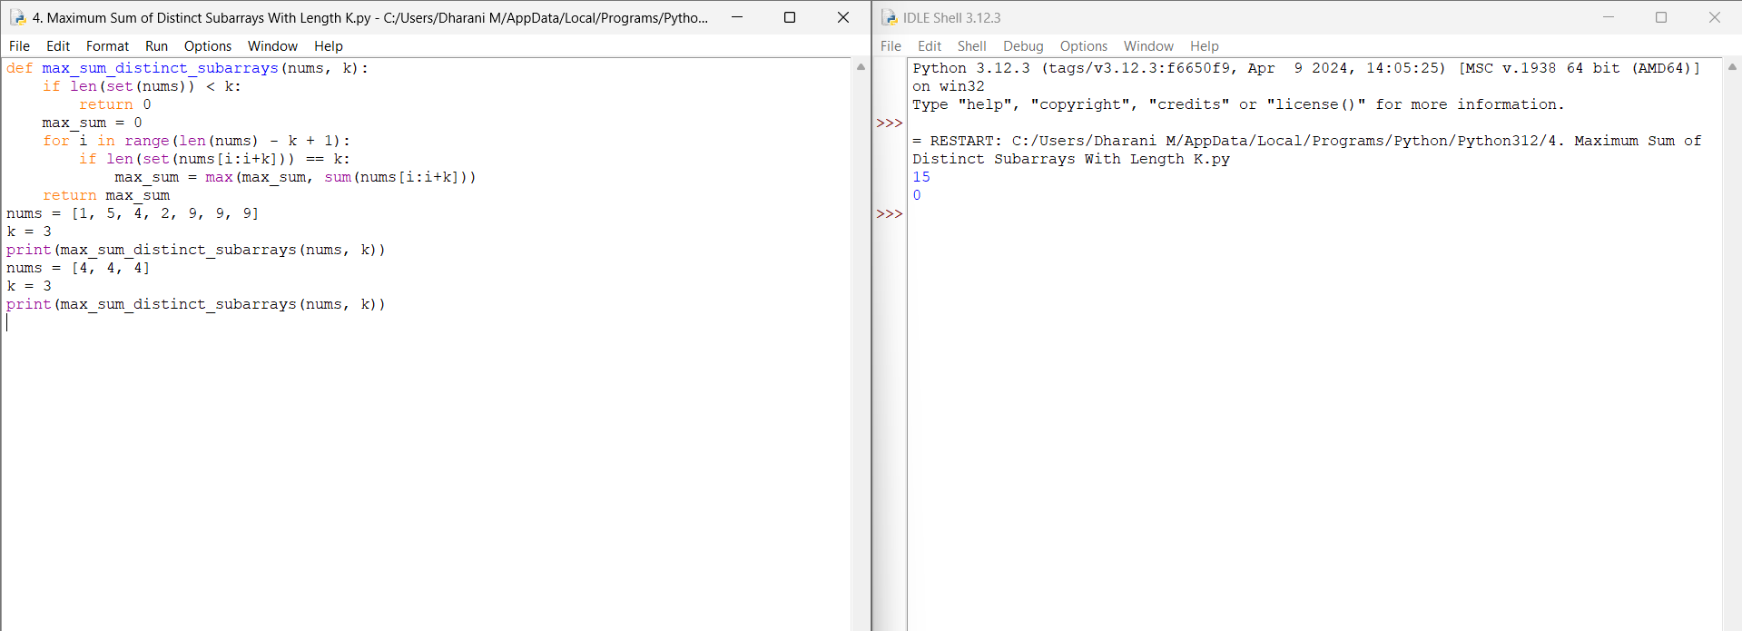

**5. Total Cost to Hire K Workers**

You are given a 0-indexed integer array costs where costs[i] is the cost of hiring the ith

worker.You are also given two integers k and candidates. We want to hire exactly k workers

according to the following rules:

● You will run k sessions and hire exactly one worker in each session.

● In each hiring session, choose the worker with the lowest cost from either the first

candidates workers or the last candidates workers. Break the tie by the smallest index.

○ For example, if costs = [3,2,7,7,1,2] and candidates = 2, then in the first hiring

session, we will choose the 4th worker because they have the lowest cost

[3,2,7,7,1,2].

○ In the second hiring session, we will choose 1st worker because they have the

same lowest cost as 4th worker but they have the smallest index [3,2,7,7,2].

Please note that the indexing may be changed in the process.

● If there are fewer than candidates workers remaining, choose the worker with the

lowest cost among them. Break the tie by the smallest index.

● A worker can only be chosen once.

Return *the total cost to hire exactly* k *workers.*

Example 1:

Input: costs = [17,12,10,2,7,2,11,20,8], k = 3, candidates = 4

Output: 11

Explanation: We hire 3 workers in total. The total cost is initially 0.

- In the first hiring round we choose the worker from [17,12,10,2,7,2,11,20,8]. The lowest

cost is 2, and we break the tie by the smallest index, which is 3. The total cost = 0 + 2 = 2.

- In the second hiring round we choose the worker from [17,12,10,7,2,11,20,8]. The lowest

cost is 2 (index 4). The total cost = 2 + 2 = 4.

- In the third hiring round we choose the worker from [17,12,10,7,11,20,8]. The lowest cost is

7 (index 3). The total cost = 4 + 7 = 11. Notice that the worker with index 3 was common in

the first and last four workers.

The total hiring cost is 11.

Example 2:

Input: costs = [1,2,4,1], k = 3, candidates = 3

Output: 4

Explanation: We hire 3 workers in total. The total cost is initially 0.

- In the first hiring round we choose the worker from [1,2,4,1]. The lowest cost is 1, and we

break the tie by the smallest index, which is 0. The total cost = 0 + 1 = 1. Notice that workers

with index 1 and 2 are common in the first and last 3 workers.

- In the second hiring round we choose the worker from [2,4,1]. The lowest cost is 1 (index 2).

The total cost = 1 + 1 = 2.

- In the third hiring round there are less than three candidates. We choose the worker from the

remaining workers [2,4]. The lowest cost is 2 (index 0). The total cost = 2 + 2 = 4.

The total hiring cost is 4.

Constraints:

● 1 <= costs.length <= 105

● 1 <= costs[i] <= 105

● 1 <= k, candidates <= costs.length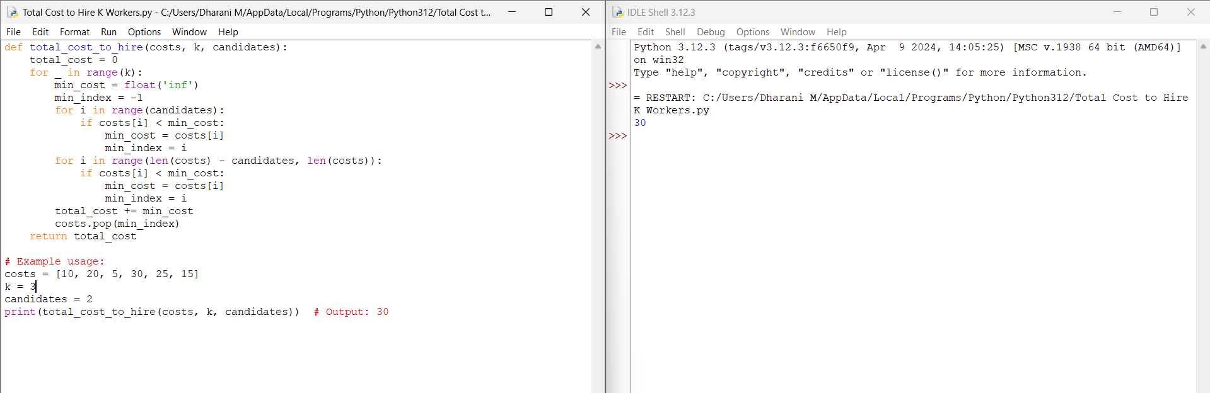

**6. Minimum Total Distance Traveled**

There are some robots and factories on the X-axis. You are given an integer array robot

where robot[i] is the position of the ith robot. You are also given a 2D integer array factory

where factory[j] = [positionj, limitj] indicates that positionj is the position of the jth factory

and that the jth factory can repair at most limitj robots.

The positions of each robot are unique. The positions of each factory are also unique. Note

that a robot can be in the same position as a factory initially.

All the robots are initially broken; they keep moving in one direction. The direction could be

the negative or the positive direction of the X-axis. When a robot reaches a factory that did

not reach its limit, the factory repairs the robot, and it stops moving.

At any moment, you can set the initial direction of moving for some robot. Your target is to

minimize the total distance traveled by all the robots.

Return *the minimum total distance traveled by all the robots*. The test cases are generated

such that all the robots can be repaired.

Note that

● All robots move at the same speed.

● If two robots move in the same direction, they will never collide.

● If two robots move in opposite directions and they meet at some point, they do not

collide. They cross each other.

● If a robot passes by a factory that reached its limits, it crosses it as if it does not exist.

● If the robot moved from a position x to a position y, the distance it moved is |y - x|.

Example 1:

Input: robot = [0,4,6], factory = [[2,2],[6,2]]

Output: 4

Explanation: As shown in the figure:

- The first robot at position 0 moves in the positive direction. It will be repaired at the first

factory.

- The second robot at position 4 moves in the negative direction. It will be repaired at the first

factory.

- The third robot at position 6 will be repaired at the second factory. It does not need to move.

The limit of the first factory is 2, and it fixed 2 robots.

The limit of the second factory is 2, and it fixed 1 robot.

The total distance is |2 - 0| + |2 - 4| + |6 - 6| = 4. It can be shown that we cannot achieve a

better total distance than 4.

Example 2:

Input: robot = [1,-1], factory = [[-2,1],[2,1]]

Output: 2

Explanation: As shown in the figure:

- The first robot at position 1 moves in the positive direction. It will be repaired at the second

factory.

- The second robot at position -1 moves in the negative direction. It will be repaired at the

first factory.

The limit of the first factory is 1, and it fixed 1 robot.

The limit of the second factory is 1, and it fixed 1 robot.

The total distance is |2 - 1| + |(-2) - (-1)| = 2. It can be shown that we cannot achieve a better

total distance than 2.

Constraints:

● 1 <= robot.length, factory.length <= 100

● factory[j].length == 2

● -109 <= robot[i], positionj <= 109

● 0 <= limitj <= robot.length

● The input will be generated such that it is always possible to repair every robot.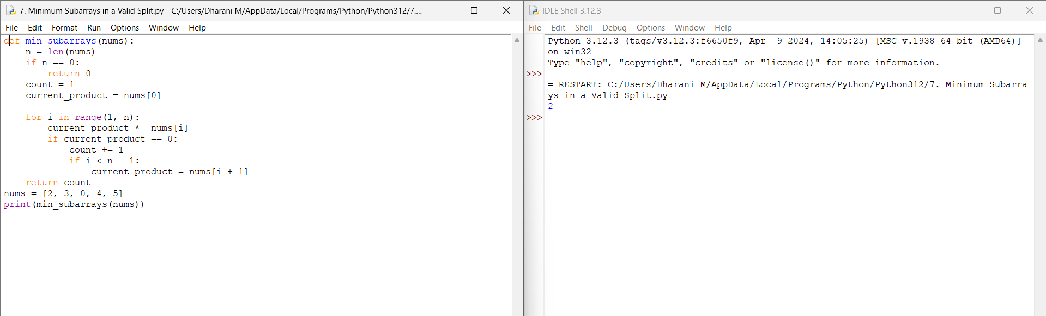

**7. Minimum Subarrays in a Valid Split**

You are given an integer array nums.Splitting of an integer array nums into subarrays is valid

if:

● the *greatest common divisor* of the first and last elements of each subarray is greater

than 1, and

● each element of nums belongs to exactly one subarray.

Return *the minimum number of subarrays in a valid subarray splitting of* nums. If a valid

subarray splitting is not possible, return -1.

Note that:

● The greatest common divisor of two numbers is the largest positive integer that

evenly divides both numbers.

● A subarray is a contiguous non-empty part of an array.

Example 1:

Input: nums = [2,6,3,4,3]

Output: 2

Explanation: We can create a valid split in the following way: [2,6] | [3,4,3].

- The starting element of the 1st subarray is 2 and the ending is 6. Their greatest common

divisor is 2, which is greater than 1.

- The starting element of the 2nd subarray is 3 and the ending is 3. Their greatest common

divisor is 3, which is greater than 1.

It can be proved that 2 is the minimum number of subarrays that we can obtain in a valid split.

Example 2:

Input: nums = [3,5]

Output: 2

Explanation: We can create a valid split in the following way: [3] | [5].

- The starting element of the 1st subarray is 3 and the ending is 3. Their greatest common

divisor is 3, which is greater than 1.

- The starting element of the 2nd subarray is 5 and the ending is 5. Their greatest common

divisor is 5, which is greater than 1.

It can be proved that 2 is the minimum number of subarrays that we can obtain in a valid split.

Example 3:

Input: nums = [1,2,1]

Output: -1

Explanation: It is impossible to create valid split.

Constraints:

● 1 <= nums.length <= 1000

● 1 <= nums[i] <= 105

**8. Number of Distinct Averages**

You are given a 0-indexed integer array nums of even length.

As long as nums is not empty, you must repetitively:

● Find the minimum number in nums and remove it.

● Find the maximum number in nums and remove it.

● Calculate the average of the two removed numbers.

The average of two numbers a and b is (a + b) / 2.

● For example, the average of 2 and 3 is (2 + 3) / 2 = 2.5.

Return *the number of distinct averages calculated using the above process*.Note that when

there is a tie for a minimum or maximum number, any can be removed.

Example 1:

Input: nums = [4,1,4,0,3,5]

Output: 2

Explanation:

1. Remove 0 and 5, and the average is (0 + 5) / 2 = 2.5. Now, nums = [4,1,4,3].

2. Remove 1 and 4. The average is (1 + 4) / 2 = 2.5, and nums = [4,3].

3. Remove 3 and 4, and the average is (3 + 4) / 2 = 3.5.

Since there are 2 distinct numbers among 2.5, 2.5, and 3.5, we return 2.

Example 2:

Input: nums = [1,100]

Output: 1

Explanation:

There is only one average to be calculated after removing 1 and 100, so we return 1.

Constraints:

● 2 <= nums.length <= 100

● nums.length is even.

● 0 <= nums[i] <= 100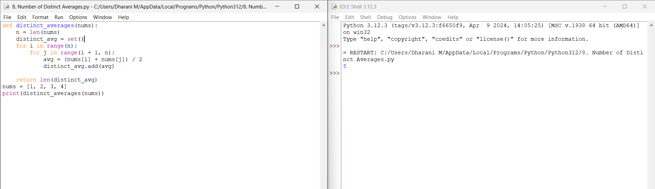

**9. Count Ways To Build Good Strings**

Given the integers zero, one, low, and high, we can construct a string by starting with an

empty string, and then at each step perform either of the following:

● Append the character '0' zero times.

● Append the character '1' one times.

This can be performed any number of times.A good string is a string constructed by the

above process having a length between low and high (inclusive).

Return *the number of different good strings that can be constructed satisfying these*

*properties.* Since the answer can be large, return it modulo 109 + 7.

Example 1:

Input: low = 3, high = 3, zero = 1, one = 1

Output: 8

Explanation:

One possible valid good string is "011".

It can be constructed as follows: "" -> "0" -> "01" -> "011".

All binary strings from "000" to "111" are good strings in this example.

Example 2:

Input: low = 2, high = 3, zero = 1, one = 2

Output: 5

Explanation: The good strings are "00", "11", "000", "110", and "011".

Constraints:

● 1 <= low <= high <= 105

● 1 <= zero, one <= low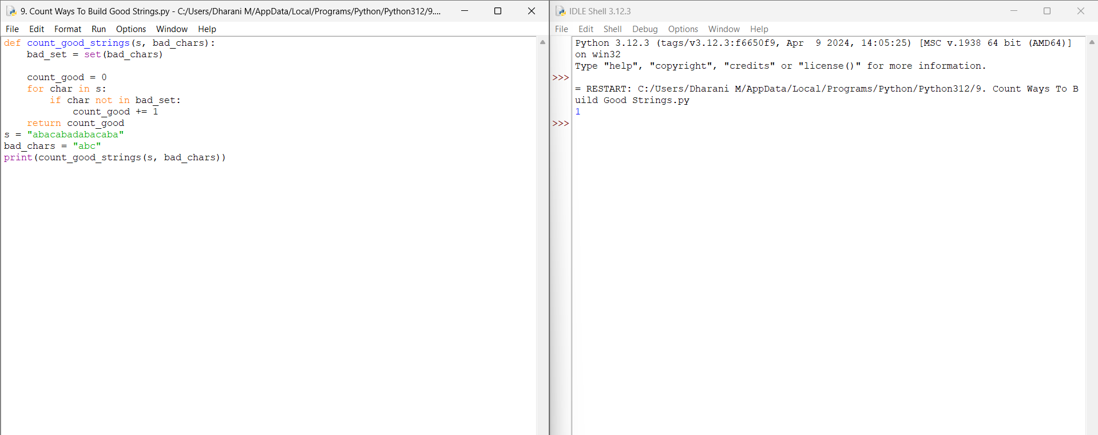

**10. Most Profitable Path in a Tree**

There is an undirected tree with n nodes labeled from 0 to n - 1, rooted at node 0. You are

given a 2D integer array edges of length n - 1 where edges[i] = [ai, bi] indicates that there is

an edge between nodes ai and bi in the tree.

At every node i, there is a gate. You are also given an array of even integers amount, where

amount[i] represents:

● the price needed to open the gate at node i, if amount[i] is negative, or,

● the cash reward obtained on opening the gate at node i, otherwise.

The game goes on as follows:

● Initially, Alice is at node 0 and Bob is at node bob.

● At every second, Alice and Bob each move to an adjacent node. Alice moves towards

some leaf node, while Bob moves towards node 0.

● For every node along their path, Alice and Bob either spend money to open the gate at

that node, or accept the reward. Note that:

○ If the gate is already open, no price will be required, nor will there be any cash

reward.

○ If Alice and Bob reach the node simultaneously, they share the price/reward

for opening the gate there. In other words, if the price to open the gate is c,

then both Alice and Bob pay c / 2 each. Similarly, if the reward at the gate is c,

both of them receive c / 2 each.

● If Alice reaches a leaf node, she stops moving. Similarly, if Bob reaches node 0, he

stops moving. Note that these events are independent of each other.

Return *the maximum net income Alice can have if she travels towards the optimal leaf node.*

Example 1:

Input: edges = [[0,1],[1,2],[1,3],[3,4]], bob = 3, amount = [-2,4,2,-4,6]

Output: 6

Explanation:

The above diagram represents the given tree. The game goes as follows:

- Alice is initially on node 0, Bob on node 3. They open the gates of their respective nodes.

Alice's net income is now -2.

- Both Alice and Bob move to node 1.

Since they reach here simultaneously, they open the gate together and share the reward.

Alice's net income becomes -2 + (4 / 2) = 0.

- Alice moves on to node 3. Since Bob already opened its gate, Alice's income remains

unchanged.

Bob moves on to node 0, and stops moving.

- Alice moves on to node 4 and opens the gate there. Her net income becomes 0 + 6 = 6.

Now, neither Alice nor Bob can make any further moves, and the game ends.

It is not possible for Alice to get a higher net income.

Example 2:

Input: edges = [[0,1]], bob = 1, amount = [-7280,2350]

Output: -7280

Explanation:

Alice follows the path 0->1 whereas Bob follows the path 1->0.

Thus, Alice opens the gate at node 0 only. Hence, her net income is -7280.

Constraints:

● 2 <= n <= 105

● edges.length == n - 1

● edges[i].length == 2

● 0 <= ai, bi < n

● ai != bi

● edges represents a valid tree.

● 1 <= bob < n

● amount.length == n

● amount[i] is an even integer in the range [-104, 104].